NHS Flex for the Future Programme

Action Planning

In conjunction with
NHS England and NHS Improvement
- Introduction

Contents

- Introduction
- Workshop summary &
key concepts
- Template Action Plan
- Agenda for Action Planning
session
- Further tools & references

If you have questions about the programme please get in touch:
Melissa.Buntine@timewise.co.uk
weworkflexibly@nhs.net

Thank you for taking part in the NHS Flex for the Future programme and being a member of the Flexible Working Change Team for your organisation.
Each of the six workshops in the NHS Flex for the Future programme has an accompanying booklet like this one, containing reference material and tools to support you to learn more and take action in your organisation.

Welcome to the fourth of our Booklets supporting the NHS Flex for the Future programme. Inside this booklet you’ll find a template Action Plan and suggested agenda for an action planning session.
The workshop slides and recording of the live workshop are also available in the Resource Library together with a set of template slides for a leadership engagement session, and a copy of the NHS Cost Calculator tool and the draft Case for Change tool.

- Workshop summary and key concepts
The NHS Flex for the Future framework provides the backbone of our action planning and supports the identification of priorities for each NHS organisation – helping you to define where to leverage action to define and embed flexibility. Our Workshop 3 Tool was an enabler to rank where you think your organisation sits in terms of its level of maturity for each of the elements within the NHS Flex for the Future programme model. The scores from this activity, together with the outputs from your organisational data collection and analysis, should have guided you to reflect on your priorities for action. In your discussions with your stakeholders, you may decide to do more in areas where you are already strong, or focus on areas where you assess the current level of maturity as lower.

The Action Plan template provides space to explain your plans to take action in each of the six pillars which make up the NHS Flex for the Future Framework:
- Leadership and culture of trust
- Flexible working policy and process
- Manager capability and support
- Employer brand and talent acquisition
- Inclusive career paths and progression
- Social responsibility and advocacy

We recommend your Action Plan comprises of SMART Actions and considers any linked change/workforce initiatives that are ongoing.
- Action Plan for …(name of organisation)…………….

Guidance notes
You may wish to use the suggested agenda at 4. In this booklet, to prepare for and run your change team action planning session. Gather the outputs from your work on the programme so far – insights from your data collection and analysis, from discussions with stakeholders and your SRO, and from previous change team meetings. The self-assessments you’ve done on where your organisation is currently against the programme framework will also be useful inputs.
When completing your plan, we recommend you complete sections 1 and 3-8, and then return to fill in section 2, as this is a summary of the detail in sections 3-8. You may find section 2 useful as a ‘quick view’ of your plans to share with a wider audience, and to report against when you are reviewing progress against your plan.
Use the ideas from the workshop slides together with your own, to identify actions to take in each section. You will notice that the suggested outcomes we spoke about in the workshop are pre-populated for you in each section of the plan. You will be able to detail the most appropriate actions for your organisation to achieve them, and will also be able to add your own ideas for other outcomes and actions.
And remember – this is a space to capture and plan the action you’re taking – no matter how big or small. This is not a ‘once-and-done’, it should be used as a live document to refer back to and update with your progress and as priorities change. Some of you are already mid-way through actions and you can certainly capture these here as well, and some of the actions here will be aimed at generating further insight and understanding so that you can shape recommendations and solutions – and that is an important step in bringing about change.

- Your Aspirations
Please use this section to briefly summarise (these sample questions may help you):
- What you hope to achieve in the next 3-6 months? And the following 6?
- How does this fit with your broader strategic objectives?
- What impact do you hope to achieve on attraction and retention through better use of flexible working?
- What are the priority actions you are going to take towards achieving this?

- Dashboard – Summary of Year One outcomes, activities and indicators
NHS Flex for the Future Framework | Main activities | Expected outcomes  (suggested minimum provided in grey, please add) | Success indicators
Leadership and culture of trust |  | Use of a dashboard or workforce report that enables the board to monitor progress against defined flexible working metrics, with an identified Senior Nurse Champion
Flexible working policy and process |  | Evidence of communicating and adopting the flexible working policy changes recently introduced in the NHS Terms & Conditions
Manager capability and support |  | Efficient use of e-rostering with an audit of the level to which team rostering are used to facilitate flexible working
Employer brand and talent acquisition |  | A minimum of 25% of permanent roles are advertised with clear flexible working options outlined (this is in the context of the national average currently at 14% so this represents an initial stretch target)
Inclusive career paths and progression |  | Those working flexibly have access to training and promotion and this is monitored
Social responsibility and advocacy |  | The organisation shares best practice and learns from others

- Leadership and culture of trust – Current status and plan
Your self-assessment on leadership and culture – include key findings from your data and level of maturity against the framework
Your ambition for improvement over the coming year
Your priorities and actions for the coming year
(including actions that have been taken as part of this programme so far as well as planned activities)
- Flexible working policy and process – Current status and plan
Your self-assessment on flexible working policy and process – include key findings from your data and level of maturity against the framework
Your ambition for improvement over the coming year
Your priorities and actions for the coming year
(including actions that have been taken as part of this programme so far as well as planned activities)

- Manager capability and support – Current status and plan
Your self-assessment on manager capability & support – include key findings from your data and level of maturity against the framework
Your ambition for improvement over the coming year
Your priorities and actions for the coming year
(including actions that have been taken as part of this programme so far as well as planned activities)

- Employer brand and talent acquisition – Current status and plan
Your self-assessment on employer brand & talent acquisition – include key findings from your data and level of maturity against the framework
Your ambition for improvement over the coming year
Your priorities and actions for the coming year
(including actions that have been taken as part of this programme so far as well as planned activities)

- Inclusive career paths and progression – Current status and plan
Your self-assessment on inclusive career paths & progression – include key findings from your data and level of maturity against the framework
Your ambition for improvement over the coming year
Your priorities and actions for the coming year
(including actions that have been taken as part of this programme so far as well as planned activities)

- Social responsibility and advocacy – Current status and plan
Your self-assessment on social responsibility & advocacy – include key findings from your data and level of maturity against the framework
Your ambition for improvement over the coming year
Your priorities and actions for the coming year
(including actions that have been taken as part of this programme so far as well as planned activities)

- Internal Change Team – Action Planning session
Introduction | Aim of the session: to build on your initial action planning session held after Workshop 3, and to develop your organisational Action Plan, populated with details of ongoing & proposed activities, outcomes and success indicators.
Agenda | - Review of actions from last meeting  Change team Leader and others update on actions following on from, and outputs from initial action planning session. Review your action log, if you are keeping one.  - Workshop Four  Consider and share key learnings / take aways from this workshop. Discuss what you found interesting and useful, and implications for your own change project.  - Inputs into action planning  Review outputs from initial action planning session, insights from data collection/analysis and your team’s assessments of your current level of maturity against the framework. Ensure everyone attending is familiar with these beforehand.  List out the current workforce initiatives / projects that you are aware of taking place within the organisation, which you need to align your work on flexibility to.  - Identifying actions  Review the materials shared in Workshops 3 and 4 about what works to drive change, and the examples of different types of impact that flexible working interventions can have (see copy of slides below):  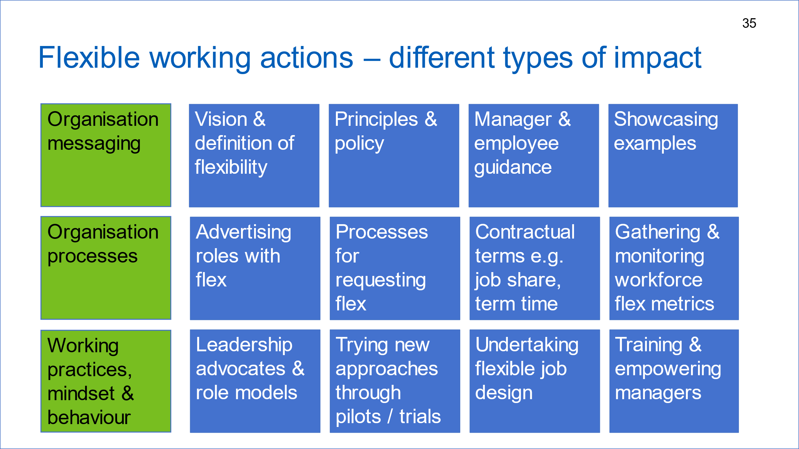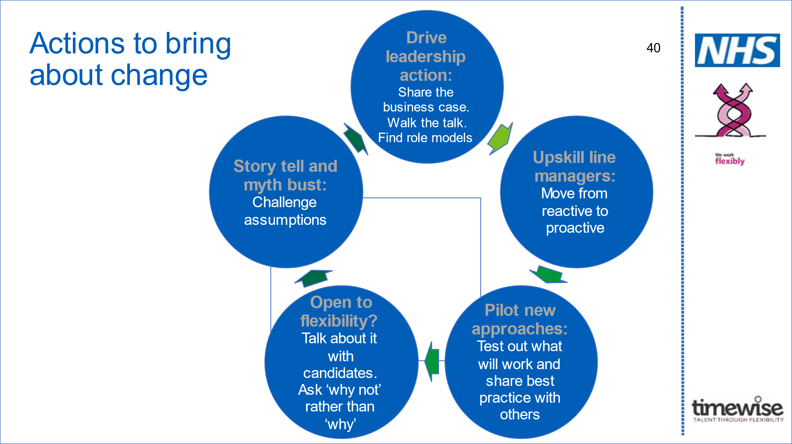  Work through each area of the Flex for the Future Framework, using the template action plan. Start by summarising your current assessment for this area, and then describing your aspiration. Discuss timings – what is realistic within a 3-6 month period, what within the first 12 months? Are there longer term organisational aspirations that you also want to capture?  Drawing ideas from the breakout sessions in workshop 4, the examples on the workshop slide deck, and your own discussions and suggestions, start to document actions for each area of the framework. Consider how you will achieve the recommended outcomes which are included in the template (and were talked about in the workshop). What other outcomes do you want from this work? What actions do you need to take to achieve these?  Ensure each action you develop is SMART (copy of slide below) and has some clear indicators against it. Think about ownership – who within the change team will take responsibility for each action? What other stakeholders do you need to engage, and how will you do this?  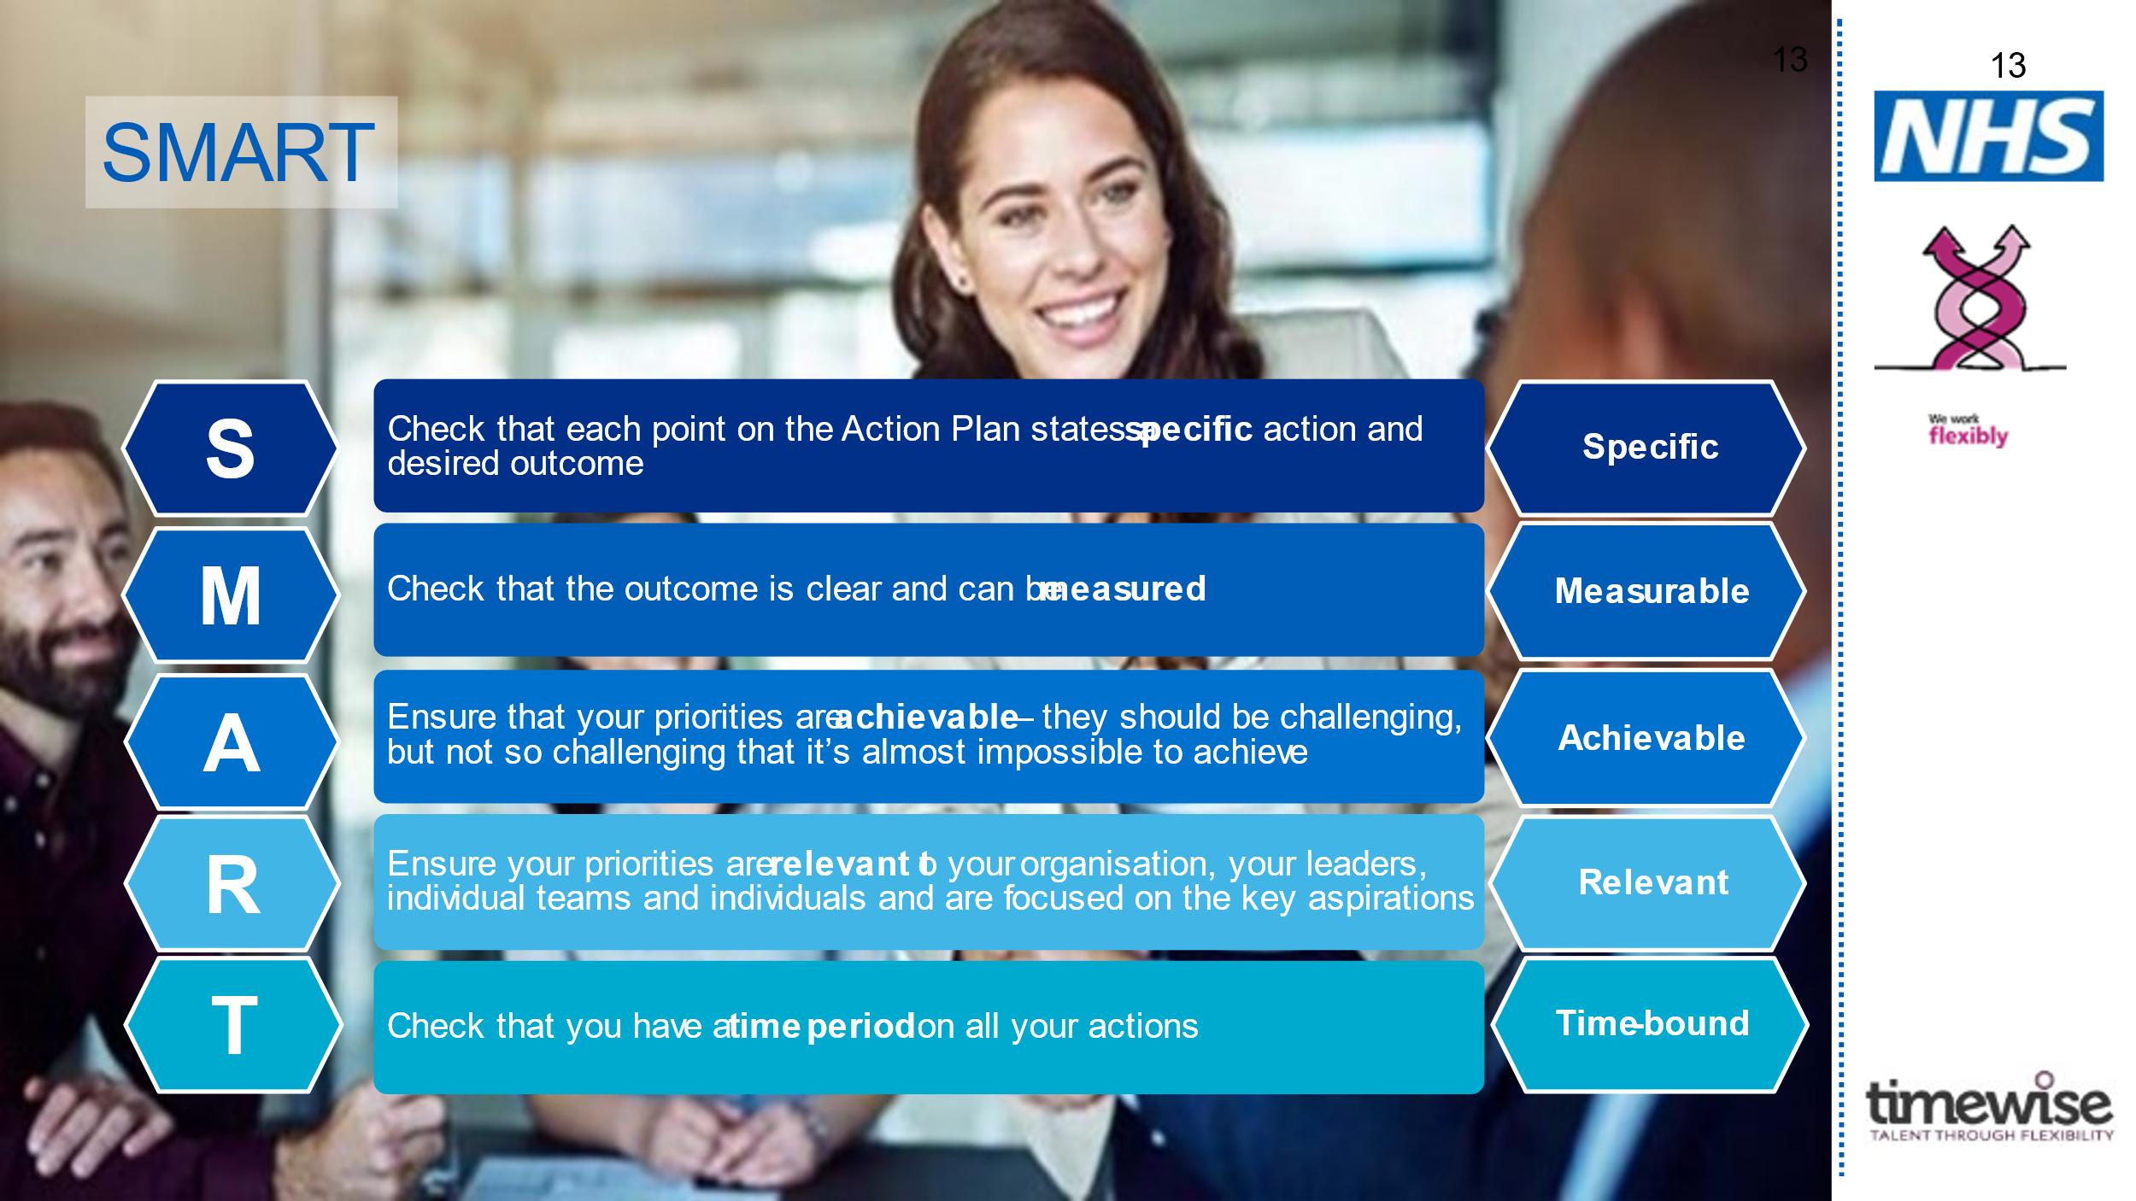  - Test & review  Once you have completed a first draft of the action plan, carve out some time either in this session or separately, to test and review it. You might do this with your SRO if they haven’t been part of the initial session, or with another stakeholder. Look at the action plan in its entirety and check:  - Does it prioritise the areas of the framework which you identified as most important to drive change within your organisation?  - Are the outcomes identified the same as those in your case for change?  - Are there a variety of action types on the plan – organisation messaging, organisation processes and organisation practices/mindset/behaviour?  Once you are happy with your plan, summarise it into section 2 within the Action Plan template.  - Next steps  Agree who and how you will get sign off of your organisational action plan. Consider whether there are resources that you need to request in order to enable you to progress with the plan, and how you will do this.  Summarise the actions identified relating to this sign off, and ensure ownership is clear.  - AOB  Any other business relating to the project raised by attendees
Wrap up and close | Capture actions arising and circulate these (with project plan if you have one) after the meeting.  Agree how and when you will next meet as a change team.

5. Further tools and references
Below is a list of relevant reading and tools which may be helpful to you as you progress your flexible working project.
Please remember to visit the resource library for all the materials we have referred to during this programme, including copies of the line manager and employee guides to Flexible Working which we shared in this module.

Further reading and resources:

- NHS Employers case study of Chesterfield Royal Hospital NHS Foundation Trust for examples of actions this Trust took

- We work flexibly for more resources, examples and case studies

- Future NHS forum on flexible working

- Timewise Knowledge Hub for general organisational resources and case study examples

Contact: If you have any questions in relation to this workshop or the programme in general please contact

melissa.buntine@timewise.co.uk or weworkflexibly@nhs.net

